Tutorial Windows + VirtualBox + OpenBSD

* Instalezi WinSCP - <https://winscp.net/eng/download.php>
* Faci Port Forwarding la masina virtuala cu OpenBSD:
  + Opresti masina virtuala
  + Click dreapta pe ea, settings

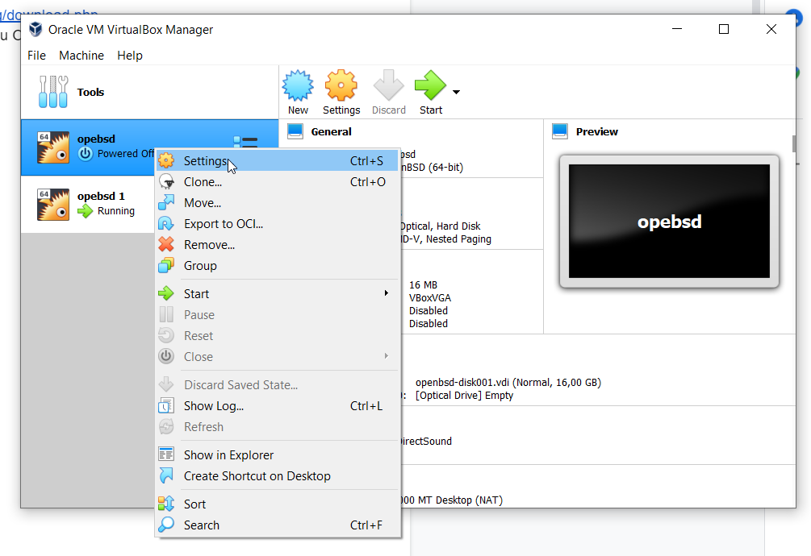

* Network -> Adapter 1 -> Advanced

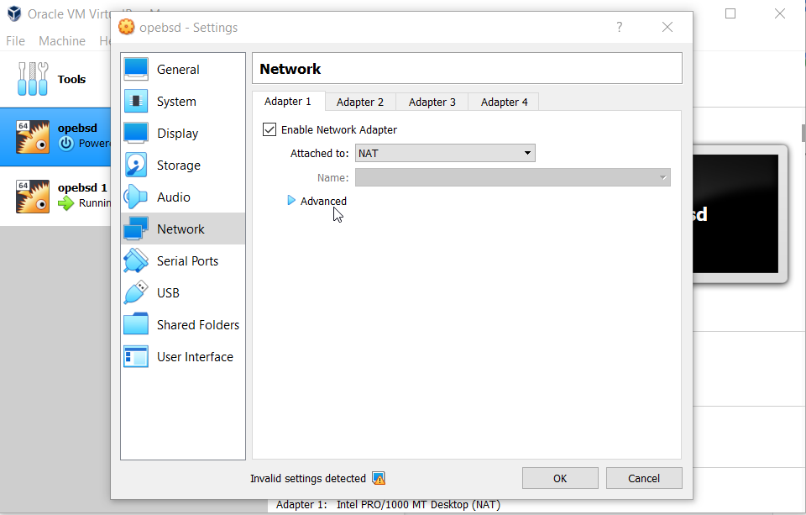

* Port Forwarding

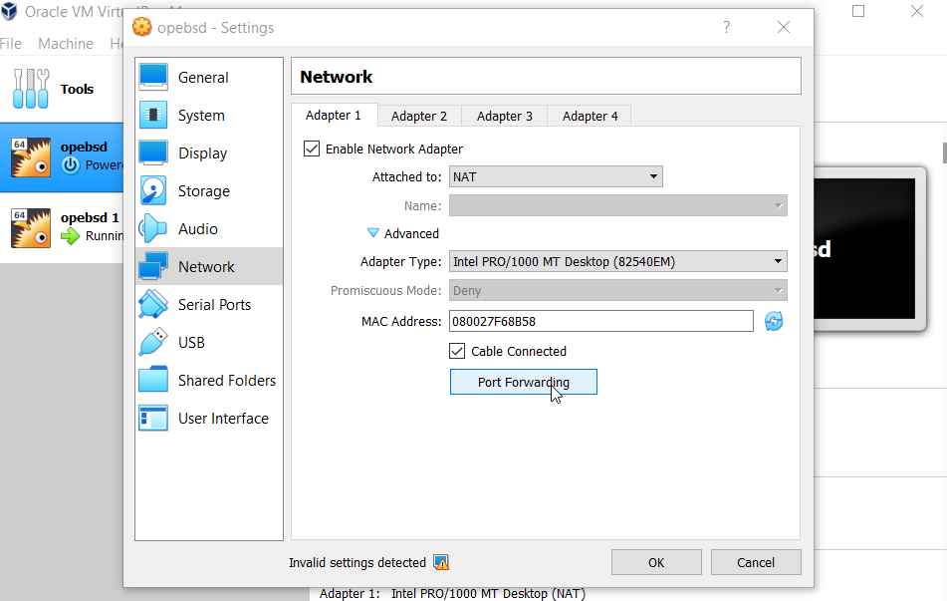

* Adaugi regula din poza

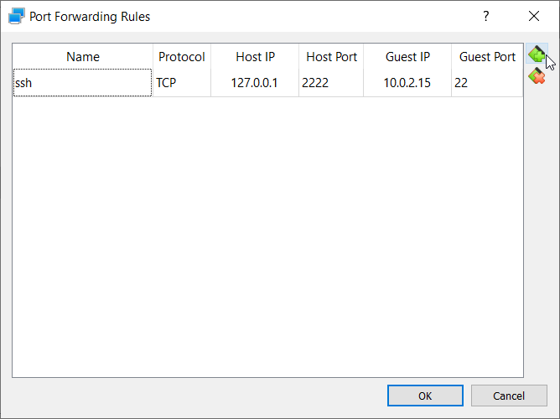

* Intri in OpenBSD
* **nano /etc/ssh/sshd_config**
* Setezi **PermitRootLogin yes** si salvezi

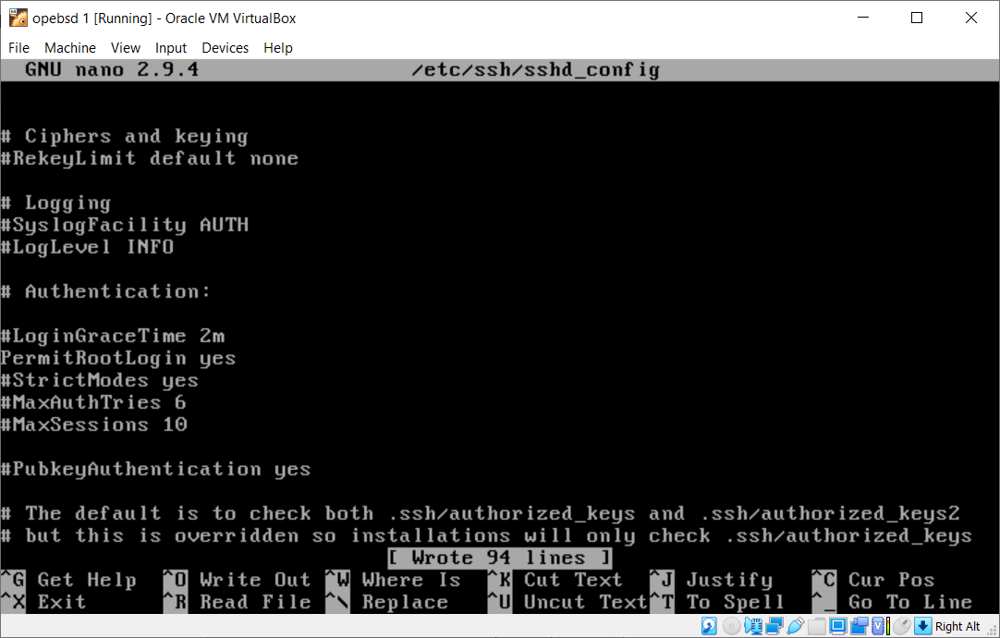

* dai **reboot**
* In WinSCP te conectezi cu datele de mai jos (parola **Student**):

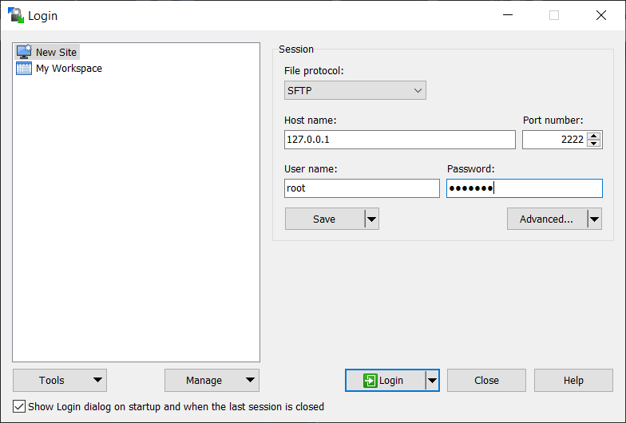

* Acum ar trebui sa ai acces la fisierele de pe masina virtuala
* 